Solar Cells Attachment Procedure and its verification method

|  |  |  |  |  |
| --- | --- | --- | --- | --- |
| Date | Writer/Modifier | Verified by | Version | Modifications |
| 2018/06/27 | P. Lepcha | P. Faure | 1 | Document creation |
| 2018/08/25 | Abhas |  | 1.1 | Pressure range addition |
| 2018/10/05 | P.Lepcha |  | 1.2 | Changes in the assembly procedure |
| 2018/10/20 | P.Lepcha |  | 1.3 | Changes in the pictures and jig position |
| 2018/12/12 | P.Lepcha |  | 1.4 | Added picture and few more details |
| 2019/11/15 | Hari |  | 1.5 | Add few more contents |
| 2020/06/20 | Hari |  | 1.6 | Updated the and add more steps |
| 2020/06/22 | P.Lepcha |  | 2.0 | Added background, edited procedures |
| 2020/06/23 | I. Bautista |  | 2.1 | Updated steps and explanation of bypass diode |
| 2021/06/15 | T.Derrick |  | 2.2 | Updated panel boards orientation as per BIRDS-5. |

**Background:**

The following figure shows parts of the solar cell:

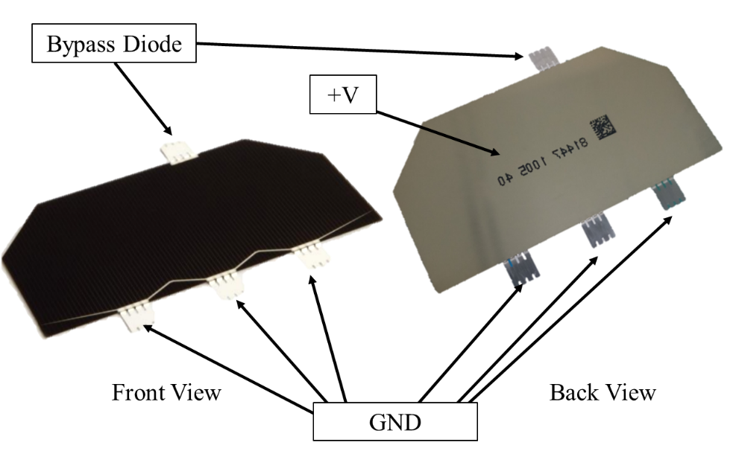

The top fringe is inbuilt bypass diode of the solar cell for the adjacent cell in the string, the backside conductive part of the solar cell is the positive and the bottom three fringes are the ground of the solar cell. In Kyutech, for 1U satellites the common combination for the solar cells is two in series. This is implemented in the PCB design of the ±Y panel and -Z panel external panels. An example of the PCB design is shown below:

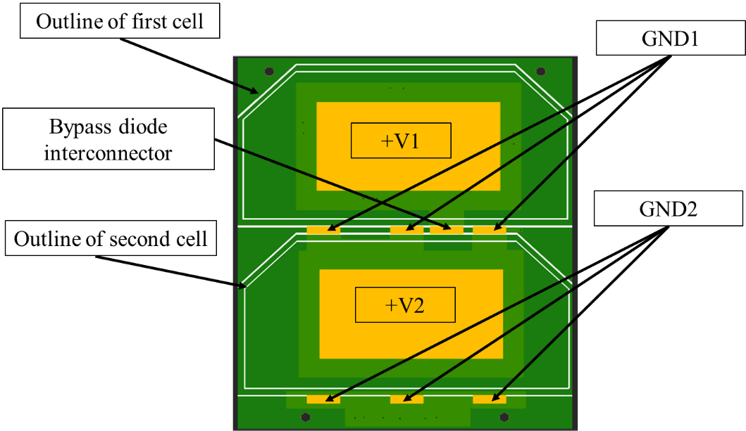

The bypass diode interconnector is connected to the +V1 of the first cell through the PCB. Since the bypass diode of the lower cell is not present, an additional diode is added in parallel to the second cell as shown in the schematic below:



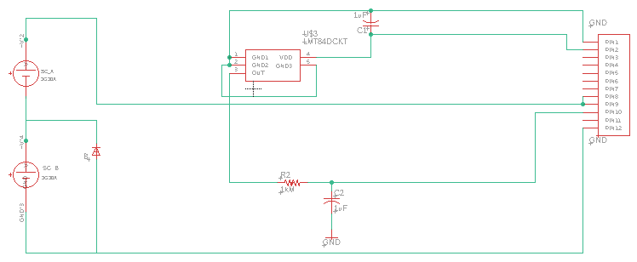

For +Z panel and -X panel PCB designs, the bypass diodes in the interconnectors cannot be used due to limited space for the interconnector, in such cases, additional diodes must be placed in the schematic, parallel to the solar cell. The upper fringe can then be cut carefully before assembly.



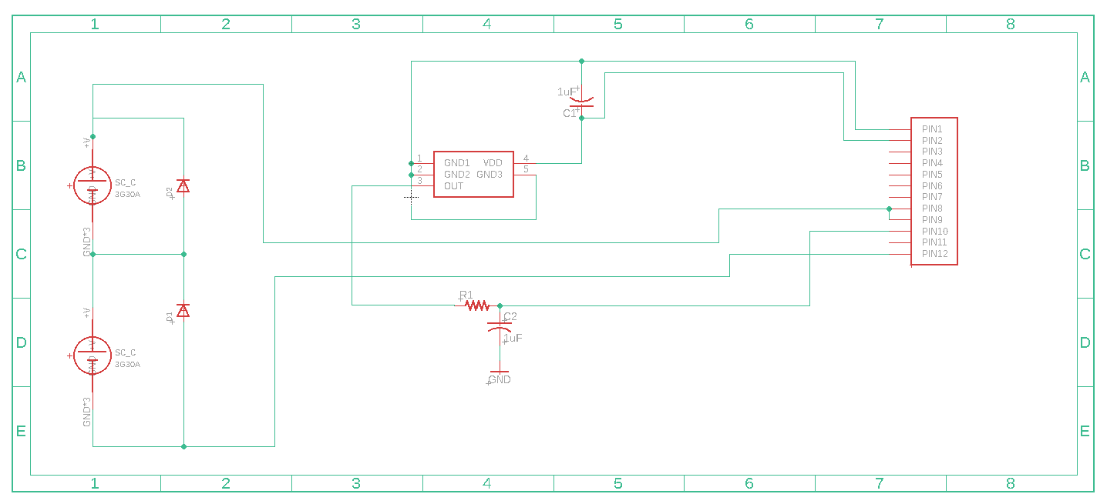

CAUTION: Do not cut the upper fringes before confirming. Please double check to make sure the fringe needs to be cut, otherwise the solar cell will be a waste.

1. **Preparation**
   1. Check grounding (table, personnel, etc…)
   2. Secure cables on the ground to mitigate trip hazard.
   3. Check all required tools are available and placed on the working space.
      * Spatulas
      * Polyimide tape
      * Measuring cups
      * Measuring scale
      * Cotton swabs
      * Cutter and/or scissors
      * Wipes
      * Ethanol or isopropyl alcohol
      * PCBs
      * Solar cells or cover glass
      * RTV
      * Conductive glue
      * Vacuum machine
      * Weights
      * Silicon jig
      * Soldering station and soldering paste (Stationed separately)
      * Trash bag
      * Vacuum Pump
      * Vacuum Pump oil (if needed)
2. **Cleaning**

Clean all tools, cups, PCBs, and surfaces with ethanol or isopropyl alcohol.

1. **Personnel grounding**

Personnel shall wear ESD mitigating wrist band, which should be properly connected to the building ground.

1. **Lower PCB preparation (Masking)**

Firstly, Measure the weight of the PCBs before to use silicon jig and then Place the silicon jig on the outskirts of the solar cell pattern as shown in the picture below.

Place the jig on the outer border of the solar cell pattern to ensure solar cells fit in the space between the jigs.

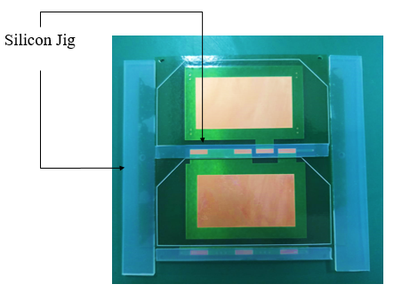

For ±Y and –Z panels

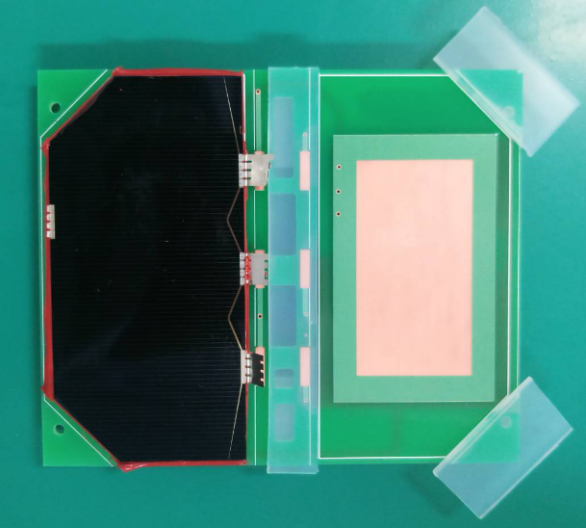

For +Z and -X panels

|  |  |  |  |
| --- | --- | --- | --- |
|  |  |  |  |

1. **RTV amount calculation**
   1. Estimate the area on which RTV shall be applied.
      * Rough RTV area = SRTV ≈ a*b – c*d

|  |
| --- |
|  |

* 1. Assume RTV thickness of 0.1mm.
     + tRTV = 0.1mm
  2. Estimate the total volume of the RTV.
     + VRTV = SRTV * tRTV
  3. Consider RTV density is 1.4g/cm3.
     + ρRTV = 1.4g/cm3
  4. Calculate required RTV mass.
     + mRTV = ρRTV * VRTV

**CAUTION:** make sure units are consistent between the different steps “a” through “e”.

* 1. Add margin to the calculated required RTV mass to consider RTV that cannot be used such as the one sticking onto the measuring cup surface or on the tools.
     + Final mRTV ≈ 2*mRTV

**NOTE 1:** roughly, for Kyutech’s satellite projects, 1 solar cell requires 1g RTV (= 0.9g cross-linker + 0.1g catalyst).

1. **RTV preparation**

RTV is composed of two different components: the cross-linker (RTV-S691 A) and the catalyst (RTV-S691 B).

**NOTE 2:** in case RTV is opened for the first time, clearly write on the bottles the opening date (MM/DD/YYYY).

|  |
| --- |
|  |

Stir, in its bottle, cross-linker (red constituent) prior to mixing it with catalyst (transparent constituent).

**CAUTION:** do not insert tools in cross-linker (red constituent) bottle if they have been in contact with catalyst (transparent constituent) and not properly cleaned with ethanol or isopropyl alcohol.

Pour each RTV constituent per the 9 (cross-linker): 1 (catalyst) ratio.

**EXAMPLE:** if 2g of RTV was estimated from step “5.e”, cross-linker (red constituent) mass shall be 1.8g and catalyst (transparent constituent) mass shall be 0.2g.

**NOTE 3:** Don’t forget to tare the scale before measuring the RTV constituents to take into account the measuring cup mass.

**Or, Note3:** Measure the weight of the cup and add 0.9g RTV (red constituent) cross linker and add 0.1 g the catalyst transparent constituent cross linker.

Example: If cup weight is 1.19g +0.9g (put RTV A) = 20.19g +0.1 g (add RTV B) = 2.29 g (total amount with cup weight)

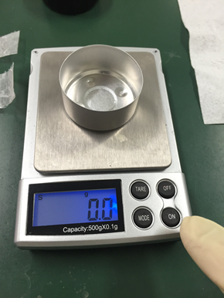

1. **RTV mixing**

Mix the two RTV constituents until the mixture becomes homogeneous.

1. **Vacuum pumping**
   1. First clean inside the vacuum pump with the ethanol properly and place the RTV sample inside the vacuum pump’s chamber.

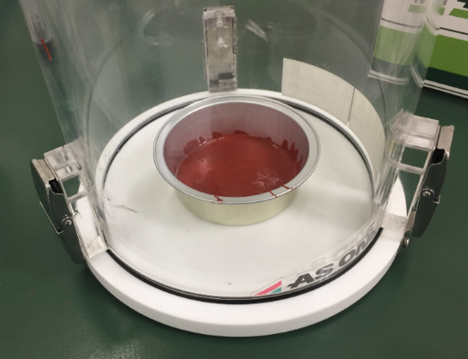

* 1. Prepare 3min timer.
  2. **Startup operation (From the manual):**

Close the pump vent valve (B); open the shut-off valve (A) to inlet port of the pump, then turn on the power switch to start operation. The pump begins running. Start the timer.

Valve B

Valve A

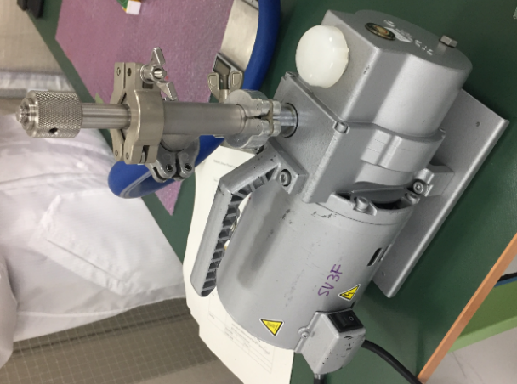

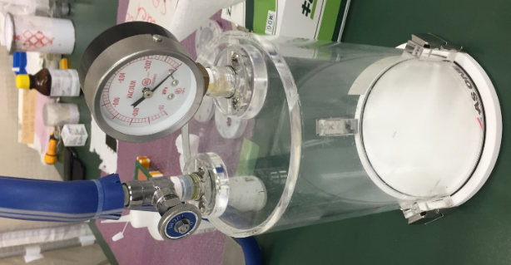

Power Switch

Pressure gauge

* 1. Adjust vacuum pump pressure to be at least 0.001MPa until 0.5MPa. For this case, keep the vacuum pump pressure at -0.06MPa.
  2. Leave the sample in vacuum condition until the end of the timer (~3min).

**NOTE 4:** as per RTV-S691’s datasheet, never leave the RTV sample in vacuum conditions more than 5min to prevent the degradation of the RTV adhesiveness characteristics.

* 1. **Shut down operation (From the manual):**

Close shut off valve (A), open pump vent valve (B), then turn off power switch of the pump.

1. **Applying RTV**

**Don’t forget to put back your ground after you finish vacuuming before applying RTV**

Apply RTV onto the desired location as homogeneously as possible and not too thick.

**NOTE 5:** as solar cells corners are the parts the most prone to breakage during vibration, shock, or handling, make sure all solar cells pattern corners are well-covered with RTV.

|  |
| --- |
|  |

1. **Applying conductive glue**

**NOTE 6:** in case conductive glue is opened for the first time, clearly write on the bottle the opening date (MM/DD/YYYY). Mix the conductive glue until it is homogenous liquid.

Apply conductive glue onto the desired location as homogeneously as possible and not too thick (6 scoops with the spatula is recommended)

As much as possible, match conductive glue thickness with RTV thickness.

Wait for at least 30 seconds if the conductive glue is too runny and make sure glue is not too dry.

|  |
| --- |
|  |

1. **Solar cell or cover glass placement**
   1. Push the vacuum pen on the elastic area and place the tip of the pen on the center of the solar cell/cover glass and release the pressure. This will grip the solar cell. Practice a few times lifting the solar cells before actual placement.

**NOTE:** Fold up the soldering part of the solar cells very carefully before placement

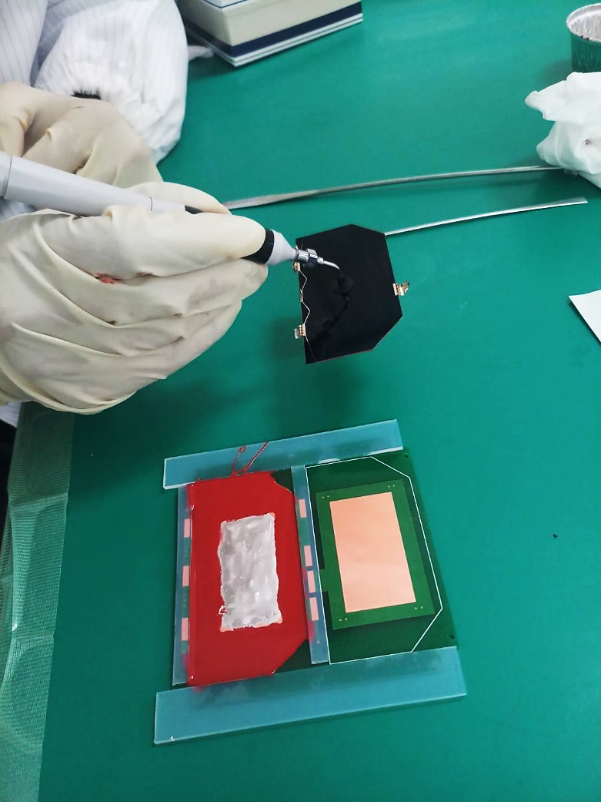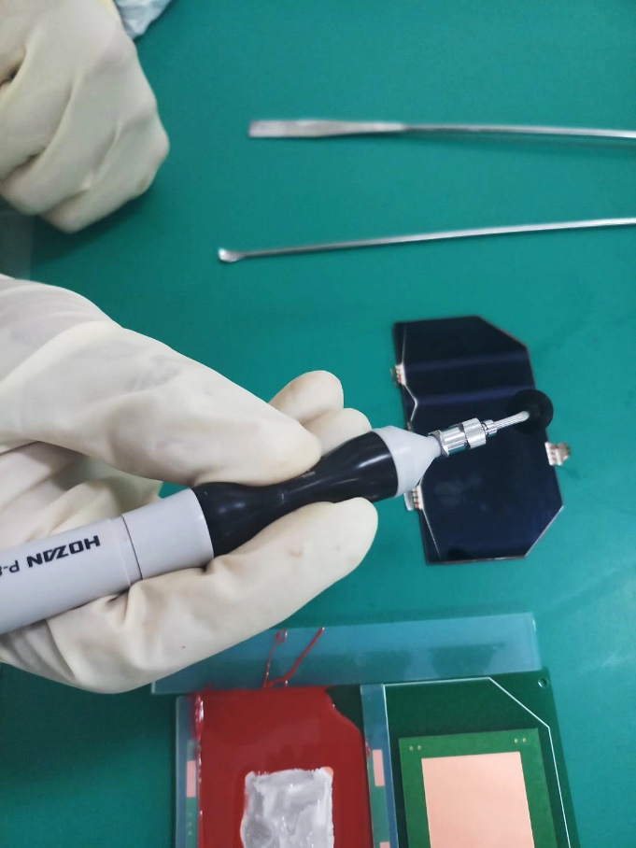

|  |
| --- |
|  |
| Move the solar cell/cover glass above the desired location slowly after getting a good grip of the vacuum pen. |
|  |

* 1. Slowly reduce the height between the solar cell/cover glass and the desired placement location.
  2. Once the solar cell/cover glass touches the desired placement location, apply the pressure on the elastic area slowly, this will drop off the solar cell.
  3. Carefully adjust the solar cell/cover glass position to match the pattern on the PCB. Move the jig if the solar cell doesn’t fit.

|  |
| --- |
|  |

**CAUTION:** do not use your finger to execute step “11.d”.

**CAUTION:** never apply top-down force onto the solar cell

|  |
| --- |
|  |
|  |

1. **Curing of RTV**

RTV-S691 requires a curing time of 24h = it requires 24h for the RTV to be fully solidified.

* 1. Place a rubber/polymer buffer of the shape that fits between the jig onto the solar cell/cover glass (the buffer shape has been already cut to fit perfectly)

|  |
| --- |
|  |

* 1. Apply the weight onto the rubber/polymer buffer slowly.

**CAUTION:** never apply the weight directly onto the solar cell/cover glass. Always use a rubber/polymer buffer between the solar cell/cover glass and the weight.

|  |
| --- |
|  |

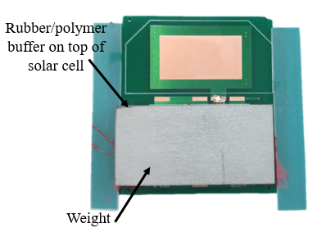

* 1. Let the RTV cure for 24h

1. **Clean and organize workplace**

After you finished attaching your solar cells/cover glass, return the workplace in its original state or better.

* + - Clean and organize your tools.
    - Return the tools that were borrowed.
    - Take the waste out.

1. **Retrieving the samples after the 24h cure**
   1. Carefully remove the weight.
   2. Carefully remove the silicon jig used for masking. Do not apply too much of force while removing the jig. Start from the easiest side.
   3. Carefully remove the rubber/polymer buffer.

**NOTE 8:** if the rubber/polymer buffer sticks to the solar cell use a soft and small/thin tools and gently remove it.

* 1. If there is RTV on the solar cell/cover glass surface or PCB, carefully remove it using a cotton swab soaked in ethanol or isopropyl alcohol.

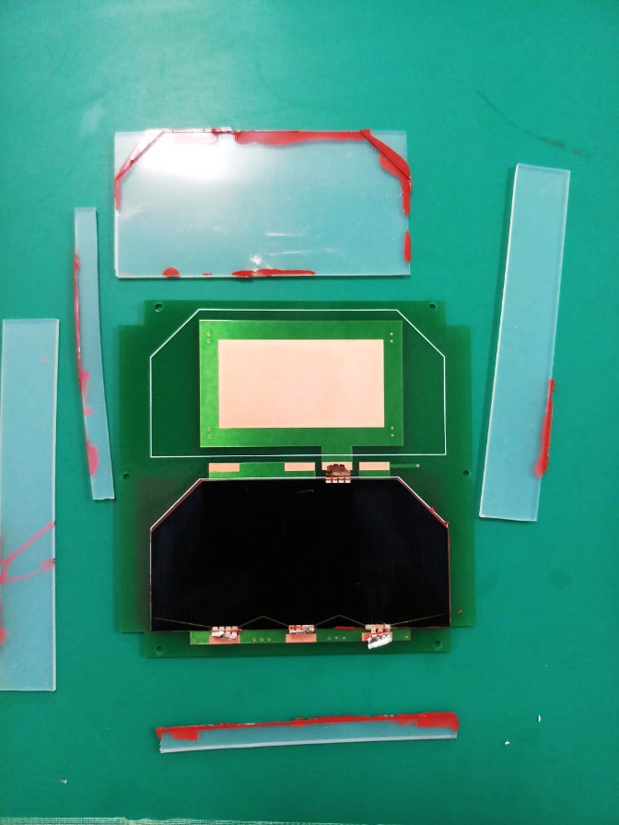

1. **Secure the 90o corners**

Apply a bit of RTV onto each solar cell/cover glass corner to secure them.

Let RTV cure until it is solidified enough (min. 4h).

|  |
| --- |
|  |

1. **Measure the Output voltage of Lower Cell** 
   1. First, check the connectivity between the anode and cathode of the solar cell for any short circuit. Sometimes, if the dotite is too runny, the positive side and the ground might get short circuited.
      * For ±Y panel and -Z panel, between upper cell anode (V1+) and cathode of lower solar cell
      * For +Z panel and -X panel between the anode bypass diode (D1) and the cathode of the lower solar cell
2. Solder the panel connectors to their respective solder mask by gently folding (without making edges) the connector then applying solder between the connectors and the PCB solder mask.

Solar cell

PCB

The fold will allow the connector to remain connected to the solar cell and PCB even with the effect of thermal stress on the PCB

1. After soldering, measure again the voltage between of the Bypass Diode and cathode of Solar panel PCB while being exposed to light source.

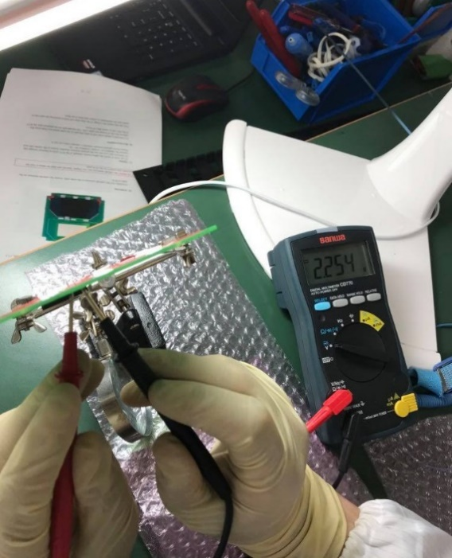

Multimeter

Multimeter

Diode

0

Solar cell on Light source

Solar cell on Light source

Note9: If the only the lower solar cell panel is exposed to the sun simulator the output voltage will be shown around 2.50 V-2.70 V but in normal light condition it shows around 2.10 V- 2.25V.

1. **Upper PCB preparation (Masking)**
   1. If the voltage levels of the lower PCBs are satisfactory, move to the assembly of upper solar cell.
   2. For upper cell attachment, follow all procedure for the preparation methods and steps from step 1 to step 10.
   3. For step 11, check the PCB design for bypass diode interconnector pad for the upper cell. Usually there is no space for the interconnector therefore the fringe needs to be cut. Carefully cut the upper solar cell’s interconnector with a scissor.

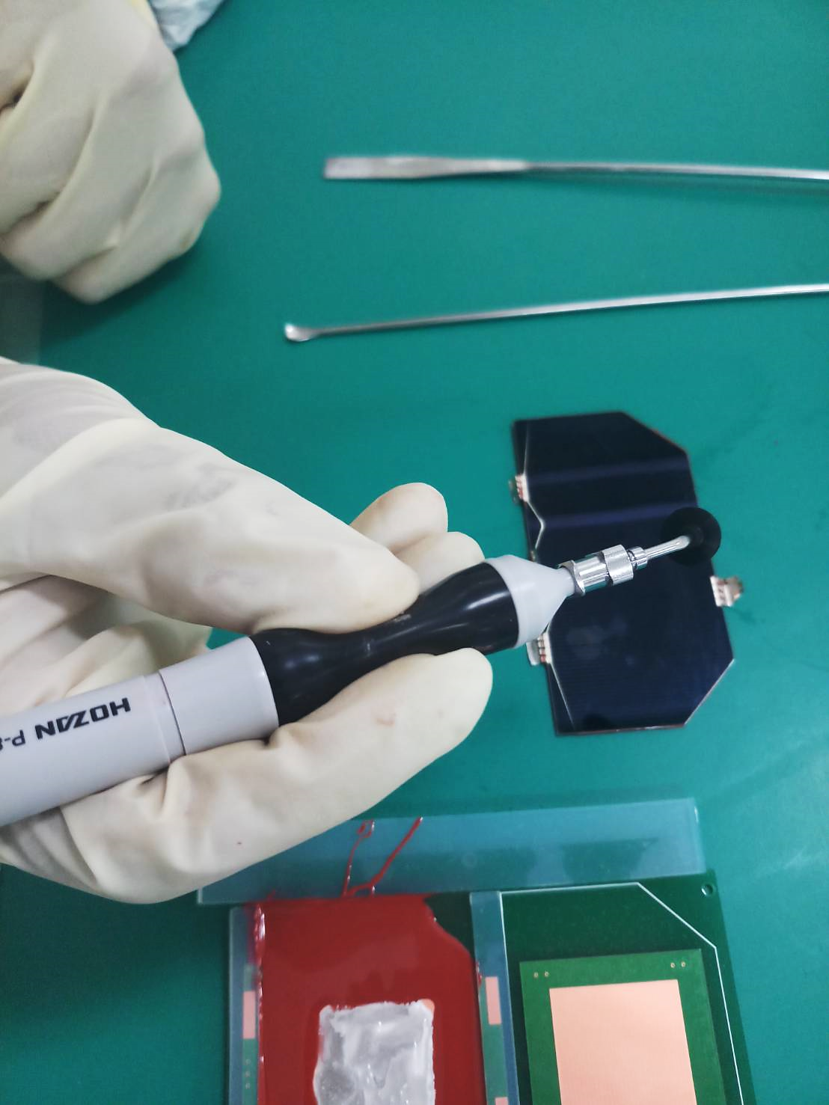



Note 10: To make it easier to cut, fold up the upper fringe of the solar cells very carefully and cut. Make sure to not drop the solar cell. Also, always double check if you have cut the fringe.

* 1. Complete rest of the procedure as shown in step 11 and 12 and wait for 24 hours for the RTV to cure.
  2. Follow step 14 and 15 for removing the silicon jig from the upper solar cell.

Upper solar cell attached

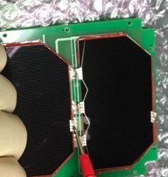

1. **Upper cell Soldering**
   1. Prior to soldering, check if the upper solar cell is connected via conductive glue to the PCB pad:
      * For ±Y panel and -Z panel, you can check from the lower cell blocking diode and via at the back of the upper cell
      * For +Z panel and -X panel, measure the voltage between the upper cell cathode and blocking diode of the upper cell (D1)
   2. Properly cover the both upper and lower solar cells of panel with rubber/polymer, this will prevent the splattering of lead on the solar cell during soldering.
   3. Maintain the Soldering rod temperature between the 270°C to 300° C.
   4. Prepare the fringes/interconnectors to be curved to allow enough room for thermal expansion on orbit. Do not stretch the fringe/interconnector to be soldered on the pads, the thermal stress might cause the connectors to break.
   5. The pads for soldering are designed on the PCBs. Solder the fringes/interconnectors for the first cell in the GND1 pads as shown in the figure in background section. Solder the second fringes/interconnectors in the GND2 pads as shown in the same figure.

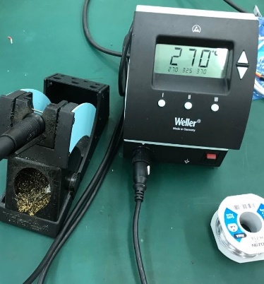 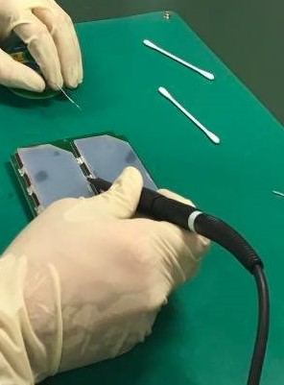

Rubber/Polymer

Soldering Station

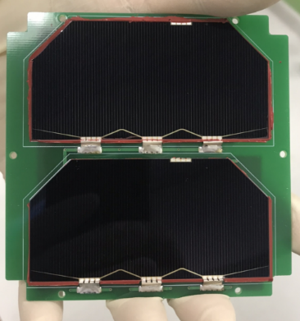

After soldering the solar Panel

**CAUTION:** the cathode terminals are very fragile. Special care shall be taken to fold the terminals and solder it on the PCB pads.

Note 11: After soldering the fringes/interconnectors on the pads of PCB, the solar cells are arranged to work in series with necessary bypass diodes placed for each cell.

1. **Solar Panel Output characterization**

Require tools and Components:

1. Multimeter
2. Sun simulator (in Clean room)
3. Pyranometer (in Clean room)
4. Solar Panel (with cells attached)
5. Electronic Load
6. Cooling Fan
7. Eye glasses
8. Stand for placing solar panels
9. Calibrate the position for placement of solar panels from the sun simulator

* The sun simulator acts like a light source for illuminating the solar cells with the similar solar irradiation as the sun. The solar irradiation in space is 1366 watts/m2. To calibrate for the same irradiation using the solar simulator, place the pyranometer on a stand and check the output voltage.
* Adjust the location of the stand according to the output voltage, and fix it at a location where the output voltage from the pyranometer is 10mV. Do not move the stand hereafter.
* Place the solar panels at the location where the pyranometer output reading was 10mV and fix the solar panel.

1. Prepare the electronic Load connection with solar Panel. Make a mating connector pin for the connector at the back of the solar panels from where the output voltage of the solar cells goes to the EPS. Take the positive and the ground pins from the connector using a cable and connect it to the electronic load.
2. The solar simulator also generates heat, keeping the solar panels in front of the simulator can heat up the solar panels. The solar cell characteristics changes with the change in temperature. Therefore, a fan must be placed to maintain the temperature of the solar panels and to measure the output voltage correctly.
3. Measure the output voltage using the electronic load from no load condition until the output voltage becomes unstable increasing the load at steps of 50mA. Typically for two cells in series, the output voltage at no load condition is about 5.0V to 5.2V.
4. Tabulate the values and make an VI curve.

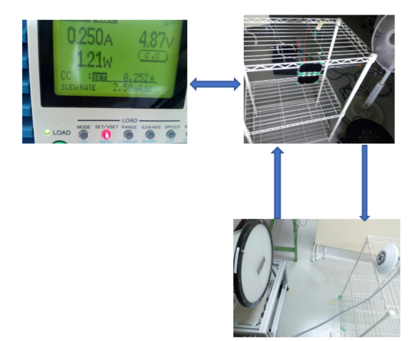

An example of solar panel characteristics of +Y panel of BIRDS-4 satellites are shown below.

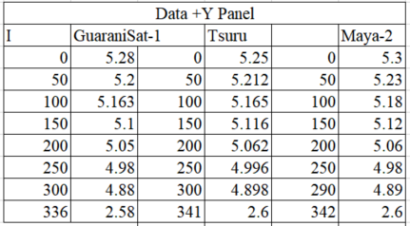

VI curve of +Y axis solar panels

1. Covering the solar cell interconnector

Cover the sharp edges of the interconnector using RTV. Do not cover all the contacts because the RTV will affect the expansion and contraction of interconnection due to the thermal stress.

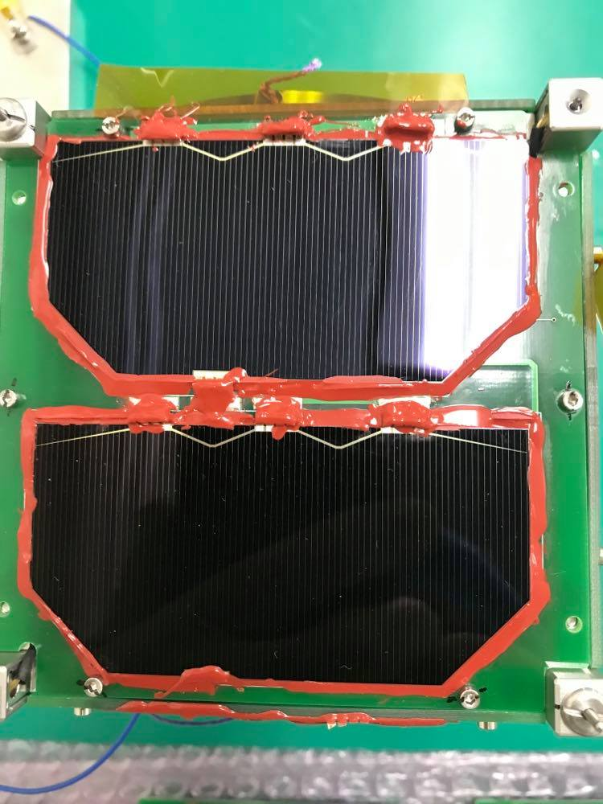

Covering the sharp edge solar cell’s interconnector

1. **Option**

If you wish to verify the adhesiveness strength of the RTV prior to thermal vacuum test or vibration test, you can use the general purpose chamber locater in the center (4F) and expose the sample(s) to vacuum condition for ~1h.

Please follow general purpose chamber’s manual when you use it.

1. **Recommendation**

It is advised to attach solar cell to only one part of the solar panel at a time since this reduces the risk of losing two solar cells. The second cell can be attached after the RTV of the first one is cured after 24 hours.

You can also check the voltage of the first solar cell before attaching the next one to make sure the attachment is correct and there is no short.